Game Design Document

Fill up the following document

1. Write the title of your project.

**BOMBARDING**

1. What is the goal of the game?

The last one to die from the bomb wins.

RUN! RUN! RUN!

1. Write a brief story of your game.

In this game, the main player sprite will be given at random. For example, in first game the player can gets a girl sprite but, in second game he can get a boy sprite. Bombs will be coming from the top and the players have to run to save their lives. As soon as the bomb touches the player it will explode, and 1 life will be deducted from that player. There will be 3 lives of each player. If a player’s lives become 0 then he will die. In addition, there will be health kits, and health drinks that will keep coming from top. There will be total 2 health kits and 3 health drinks. The player can collect all of them. If he takes all 5, then he will be immune to 5 bombs (as his lives will be increased by 5), but when the sixth bomb touches the player he will die. If all the lives are exhausted then his opponent will win the game. The users will control the main player with left and right arrow keys. Also, the players will play in a background on a ground and there will be a background music as well as songs for various purposes. There will be gameStates to make the game more interesting to play. The player who wins will be given rank – 1.There will be some texts explaining the game in short.

1. Which are the playing characters of this game?

* Playing characters are the ones who respond to the user based on the input from the user.
* Cars, monkeys, dinos, wizards, etc., are the playing characters in the game.

|  |  |  |
| --- | --- | --- |
| Number | Character Name | What can this character do? |
| 1 | Girl Sprite – Anna. | This character is the main character in the game and will be moved with left and right arrow keys and has to dodge from the bombs and collect the health kits and drinks, if he wants. |
| 2 | Boy Sprite – Axe. | This character’s role is the same as it’s predecessor. |

1. Which are the Non-Playing Characters of this game?

* Non-Playing characters are the ones that don't have an action or behavior when the user interacts with the game.
* Hurdles, stones, bananas, coins, etc., are non-playing characters in the game.

|  |  |  |
| --- | --- | --- |
| Number | Character Name | What can this character do? |
| 1 | Bombs | There will be various kinds of images of bombs that will keep on coming at random and take away the player’s 1 life. |
| 2 | Health Kits | This will boost the player’s health by increasing the player’s 1 life and saving him from 1 bomb. There will be a total of 2 health kits. |
| 3 | Health Drinks | The only difference between health drinks and health kits is that they have different images. There will be a total of 3 health drinks. |
| 4 | Background | There will be a backgound image to make the game more beautiful to play. |
| 5 | Ground | This will be the base on which the playing characters of the game will move on. |

Draw your imagination of this game. What does this game look like?

* Draw the game either on your computer or on paper.
* Add images of the game scenes to show each of the playing and non-playing characters at least once.

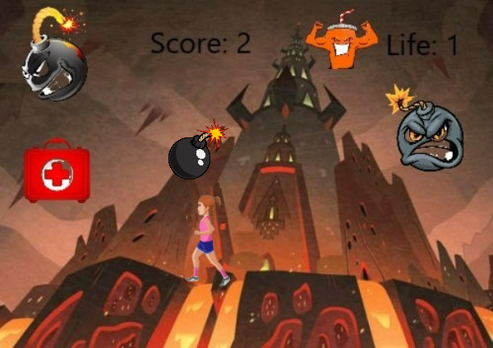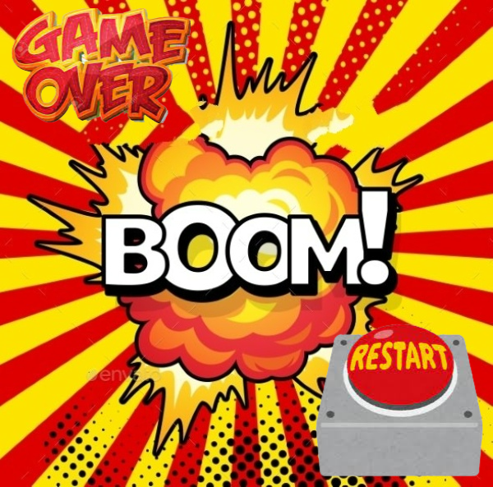

Here are the all the images of the game:

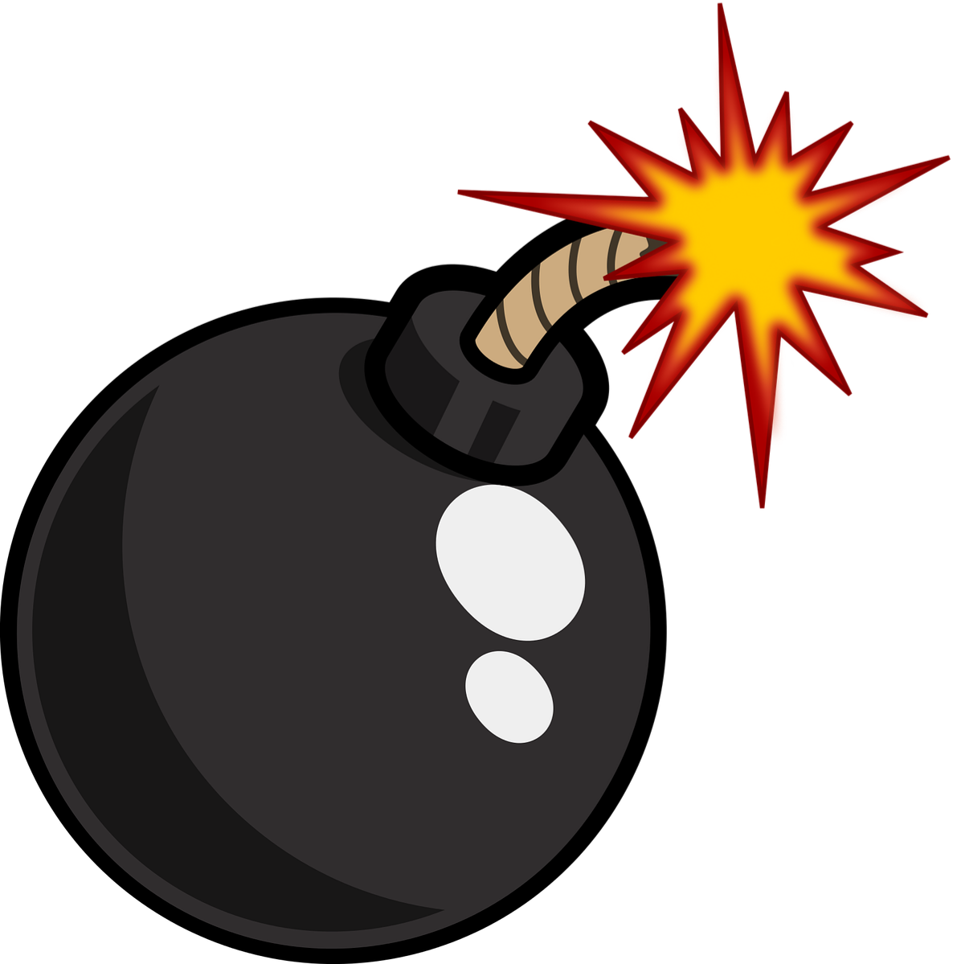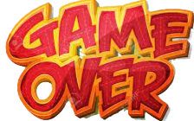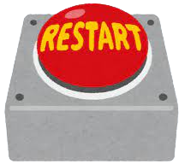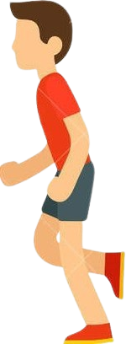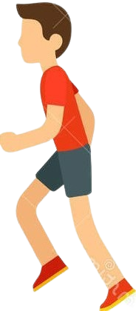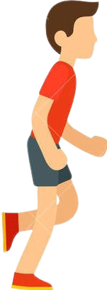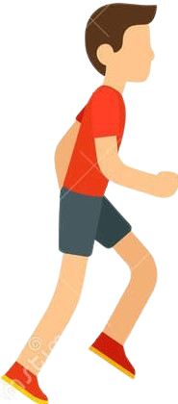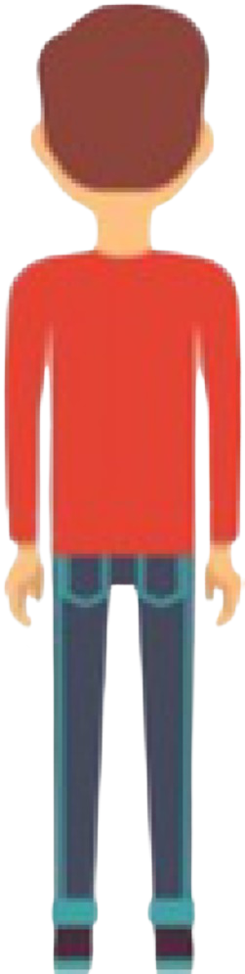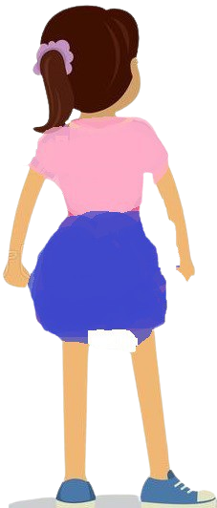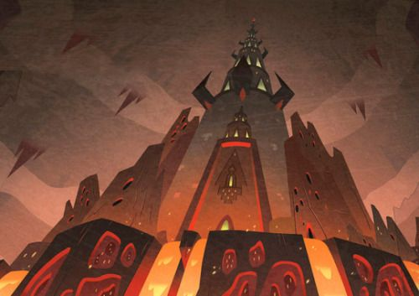

Sounds:



How do you plan to make your game engaging?

There will be various kinds of images of bombs and health kits and health drinks. Also there will be a background image of underworld that will look dangerous. There will be audio files of running and screeming (low sound) and sound files of various actions. The backgrond and watermarks from the images will be removed. The game will look and felt the best when it is played.

**XXXXXXXXXXXXXX**